LOCAL SKILL BARTER TIME BANK
@CREATIVITY THINK (9483175986/7019689991)

ABSTRACT:
Local Skill Barter Time Bank is a dynamic web application that enables people within a community to exchange skills using time credits instead of money. Users can list skills they can offer, browse others’ offerings, request 1-hour sessions, and earn or spend time credits based on completed exchanges. The platform maintains complete transparency through transaction logs and a real-time time-balance system. Admins can set global rules, monitor activity, resolve disputes, and analyze community exchange trends through a dashboard. The application is built using Django REST Framework for the backend and React with Redux for a smooth user experience..

INTRODUCTION OF THE PROJECT:
Skill bartering communities promote social cooperation by enabling individuals to exchange services using time as currency rather than money. However, manual tracking of time credits, transactions, and skill exchanges is often inefficient and prone to miscommunication.
The Local Skill Barter Time Bank system provides a centralized platform where users can publish skills, request services, and manage time-credit balances. This transparent digital ecosystem encourages community bonding, promotes equal value exchange, and ensures accountability through logs and dashboards..

PROJECT OBJECTIVES:

• Allow users to register and list skills they can offer to the community
• Enable browsing of available skills from other members
• Facilitate 1-hour skill requests and scheduling
• Transfer time credits automatically upon completion of sessions
• Display user time-balance and complete transaction history
• Provide dispute-resolution options through admin tools
• Enable admins to configure global rules such as monthly hour limits
• Monitor suspicious activity or unusual patterns
• Offer analytics and community reports for performance tracking

PROBLEM OF THE STATEMENT:
Communities often desire a barter-based skill exchange system but lack a standardized method to track exchanges, validate hours, and ensure accountability. Manual processes lead to disputes, unbalanced exchanges, or unsystematic growth.
The Local Skill Barter Time Bank solves these issues by providing a structured digital platform where time is the currency. Users earn credits for helping others and spend credits when receiving services. Admin tools ensure fairness and transparency throughout the ecosystem..

MOTIVATION OF THE PROJECT:
• Promote skill-based exchange without financial dependency
• Encourage community collaboration and volunteering
• Provide equal opportunity for all members to give and receive help
• Digitize time-credit tracking to ensure fairness
• Offer analytics for community leaders to measure growth
• Reduce disputes through clear transaction histories
• Support NGOs, student groups, and local communities

BLOCK DAIGRAM OF PROJECT:

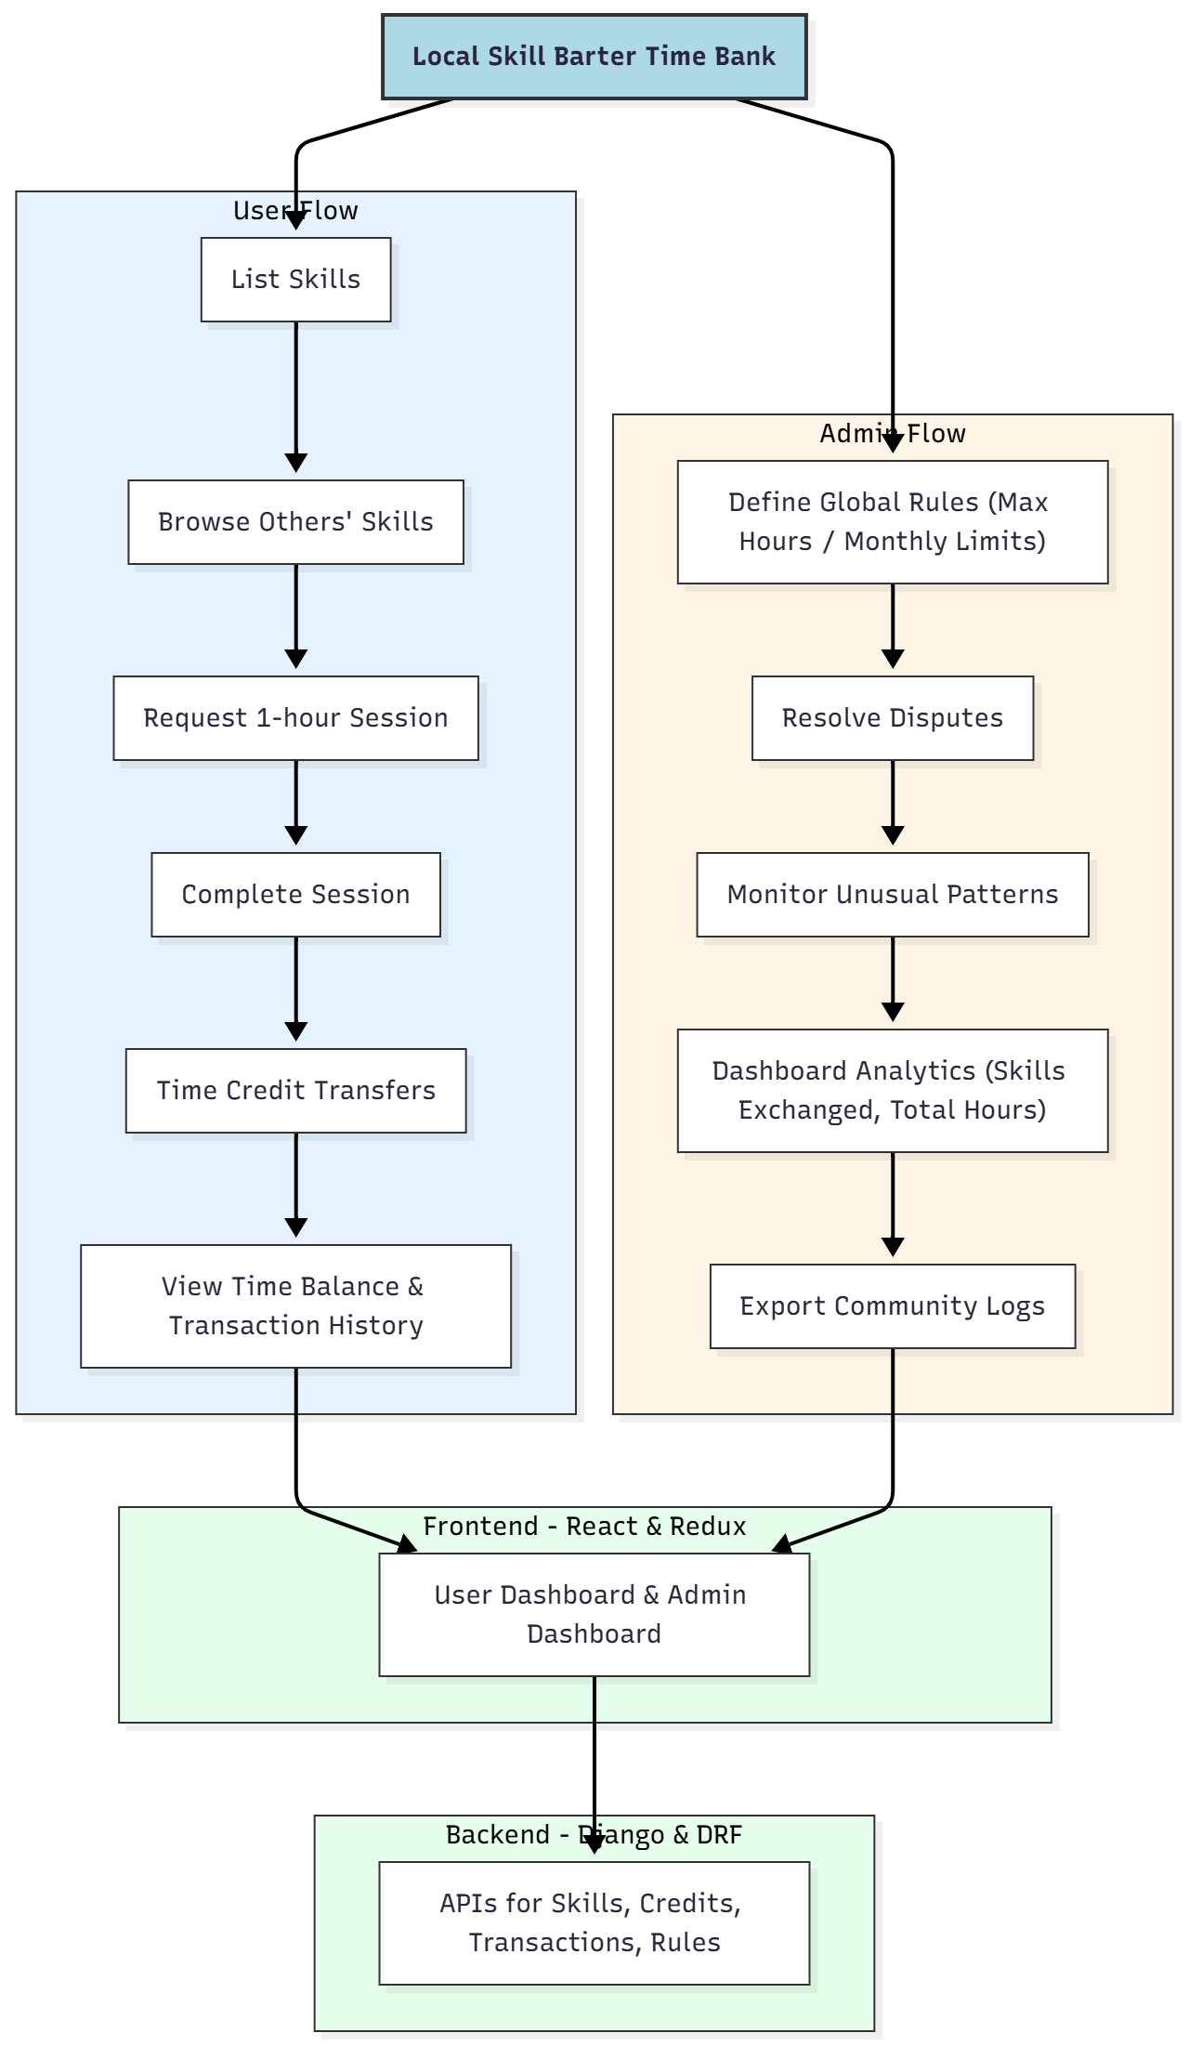

WORKING OF THE PROJECT:
Users begin by creating an account and listing the skills they can offer—such as tutoring, design help, cooking guidance, or repairs. They earn time credits for providing 1-hour sessions to others. Similarly, they can browse available skills and request sessions from other members, spending their earned time credits.
After a session is completed and confirmed, the system transfers one hour from the receiver’s account to the provider’s account. Users can view their balance and entire transaction history in real time.
Admins control the ecosystem by defining monthly hour limits, monitoring abusive patterns, and resolving disputes. The dashboard provides insights like most exchanged skills, total community hours, and active users..

SOFTWARE REQUIREMENT:
- Backend:
  - Python 3.x
  - Django
  - Django REST Framework
  - SQLite/PostgreSQL
- Frontend:
  - Node.js and npm
  - React.js
  - Axios
- Development Tools:
  - Visual Studio Code
  - Postman (for testing APIs)
  - Git/GitHub (for version control)
- Server/Deployment (Optional):
  - Gunicorn, Nginx, or Heroku/AWS for hosting

ADVANTAGES OF THE PROJECT:

• Promotes community bonding through skill-sharing
• Time-based currency ensures fairness and equality
• Transparent credit transfers and logs eliminate disputes
• Easy-to-use dashboards for both users and admins
• Supports small communities to large social groups
• Efficient analytics provide insights into community growth
• Zero money involved, ideal for NGOs and student groups

APPLICATIONS OF THE PROJECT:
• Local communities and neighborhoods
• Student groups and college clubs
• NGO skill-sharing programs
• Residential societies
• Volunteer networks
• Community learning circles

REFERENCES:

- Django REST Framework Documentation — Django Software Foundation. Django Documentation. Available: https://docs.djangoproject.com/
- Django REST Framework. DRF Documentation. Available: https://www.django-rest-framework.org/
- React. React Official Documentation. Available: https://reactjs.org/docs/getting-started.html
- Redux. Redux Documentation. Available: https://redux.js.org/introduction/getting-started
- PostgreSQL Global Development Group. PostgreSQL Documentation. Available: https://www.postgresql.org/docs/
- MySQL. MySQL Reference Manual. Available: https://dev.mysql.com/doc/
- Git. Git Documentation. Available: https://git-scm.com/doc
- Node.js. Node.js Documentation. Available: https://nodejs.org/en/docs/
- Axios. Axios Documentation. Available: https://axios-http.com/docs/intro
- Socket.io Documentation – https://socket.io/docs/

